Training Course

Find your rights with the nature

ShAki, Azerbaijan

September 1-8, 2013

Project description
This training course is aiming at empowering and developing competences of young people using outdoor as a tool in the topics of human rights and youth participation.
During a seven days programme of activities, participants - youth workers/leaders and multipliers with fewer opportunities and those from culturally diverse backgrounds from the Azerbaijan, Czech Republic, Romania, Poland, Turkey, Moldova, Georgia, will be equipped by various tools and methods of outdoor education and learn how to transfer their knowledge in their countries. They will have a chance to reflect on how to make outdoor one of the main directions of their organizations and explore the benefits of using outdoor as a tool when promoting human rights and environmental issues.

Date:
Arrival: 1th September
Departure: 8th September

Venue:
Shaki - one of the most ancient towns in the Caucasus is situated in northern Azerbaijan on the southern part of the Greater Caucasus mountain range, 325 km (202 mi) from Baku. The population of Shaki is 63,000 .The mountain forests around the area prevent the city from floods and overheating of the area during summer. It dates back to the Late Bronze Age and played a vital role in the development of Azerbaijani culture throughout the ages. The designation of a "Silk Road" connecting the West to the East directly applies to Shaki, for it was once a great silk center.

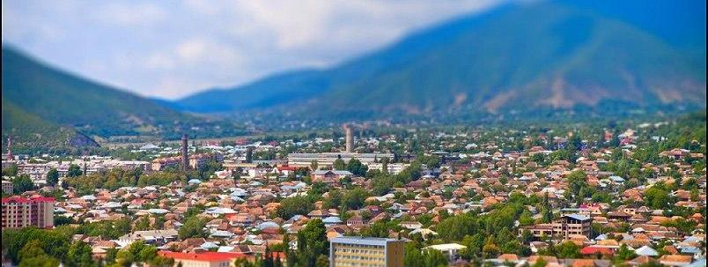
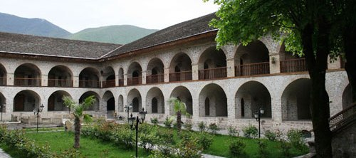
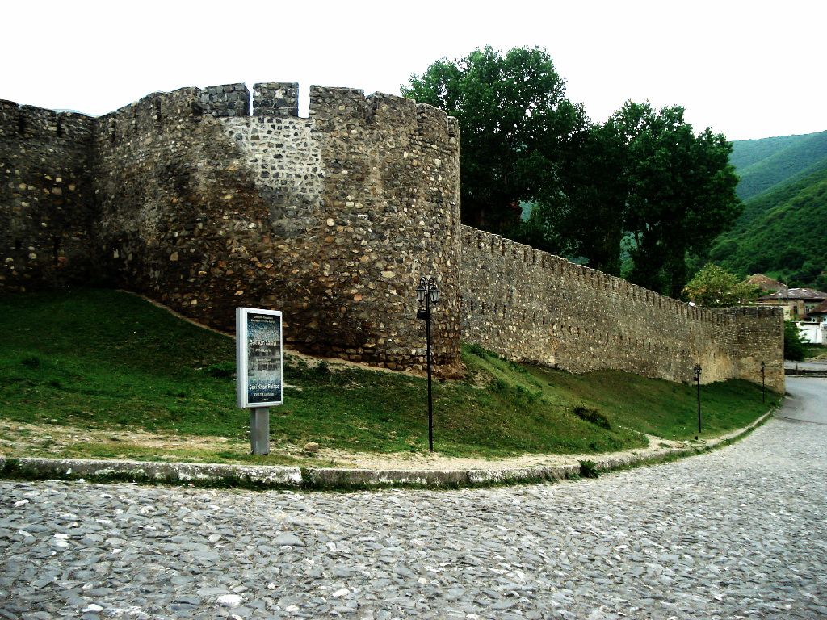
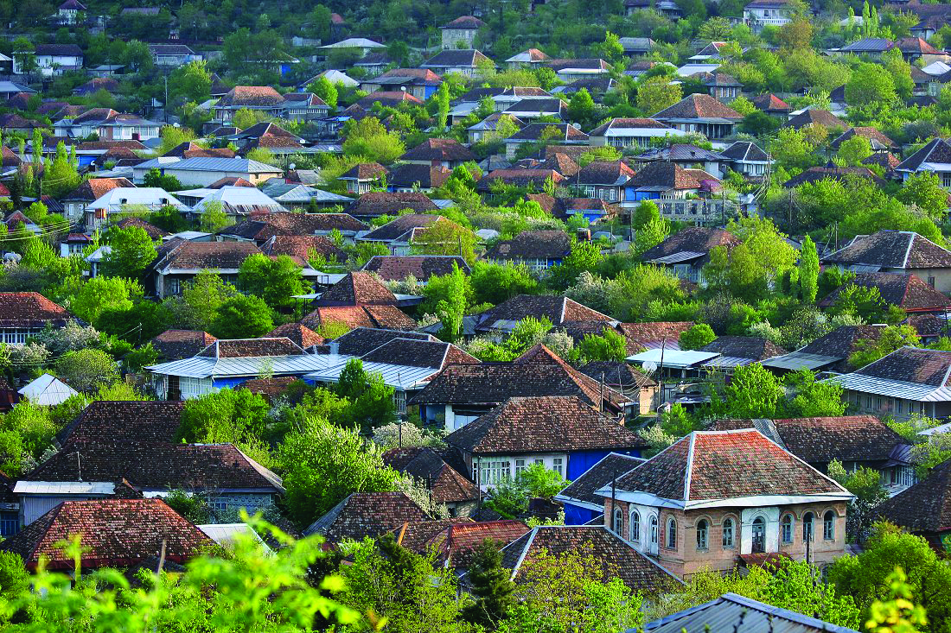
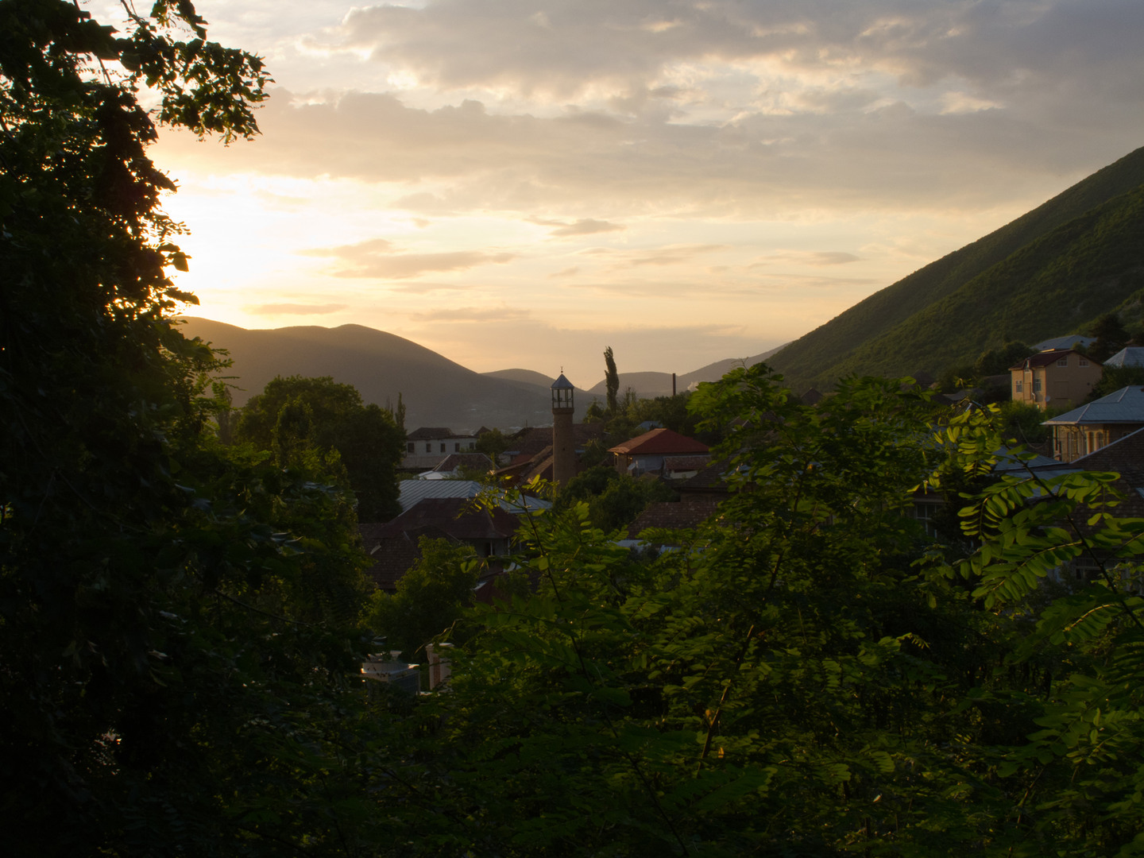

objectives:
- By promoting outdoor education, bringing together youth workers and equipping them with tools for using outdoor methods in order to address young people’s needs and promote inclusion and healthy lifestyle, the project develops solidarity and tolerance among young people.
- The universal character of outdoor education has a huge potential to help foster social cohesion in the European Union.
- Through an activity programme bringing together young people and youth from a range of countries, and devoting a part of this programme to developing future youth exchanges, youth initiatives, job shadowing and EVS projects using outdoor methods in Youth in Action.

Conditions:
As this youth exchange will be implemented in the frame of the EU Youth in Action Programme, the accommodation and food supply for all participants will be covered totally. In addition, 70 % of the travel expenses and 100 % of visa costs will be reimbursed to the participants.

transportation, accommodation and food
The training course will be held in Shaki. In the forest in the tent, three-four participants of the same sex and different nationalities will share one tent. Sleeping bads and pats are provided by the participants. There are outdoor toilets and bathrooms. The seminar room and dining room are located in the same place. Organizers will provide participants with three times food per day and two coffee breaks.
We strongly recommend participants to inform the organisers about any special needs of participants such are dietary, vegetarian or any other kind of special needs.
! Please note that if some participants will come earlier and stay longer for holiday reasons, organizers will not reimbursed additional nights.

Weather
In September the temperature will be roughly 8°- 12° C in evenings and 20°- 27° C in a day time. The activity will be held in mountainous area, soit can be colder or rainy, so please be prepared.

Transport Details
Participants have several possibilities to arrive. Most common arrival point is Baku international airport. For participants arriving from Georgia we recommend to use train connection to Baku. All participants will be picked up from the Baku International Airport and train stations. The organisers will also provide the return travel from Shaki to Baku.
Please note that if some participants will stay longer for holiday reasons, organizers will not provide them with transportation to the Airport.

Travel reimbursement
The organizers will reimburse max. 70% of participants travel costs from the home city to Shaki and from Shaki back home.
Reimbursement of your travel costs can only be done upon submitting ALL the original tickets, original invoices, boarding passes. - or upon presenting the payment evidence along with the original ticket or e-ticket (with the boarding pass wherever applicable) and submitting us the respective copies.
All the requested documents serve as supporting documentation for the Project Final Reporting (and reimbursement).
Reimbursement will be done in EURO, based on the exchange rates given by the Youth in Action Programme specifically the Executive Agency and the rules for reimbursement and reporting.
The reimbursements will be done through bank transfer to one account number for each partner organization upon receiving all the original tickets, invoices and boarding tags.
! Please note that travel between Baku and Shaki will be organised by the organisers, and that the costs for this trip has to be covered by the participants with 30% of the actual costs.

Travel Costs Limits by country
Please do not exceed your travel budget indicated below: If you have problems fitting into the travel budget, please contact the organizers before buying your ticket.
Promoter | Number of persons | From | To | Means  of transport | Total costs per person (100%)
A.R.T. Fusion | 4 | Bucharest / Romania | Baku | Plane/ Bus/ Train | 450
Foundation for Social Initiatives | 4 | Olsztyn / Poland | Baku | Plane/ Bus/ Train | 450
Be International | 4 | Brno / Czech Republic | Baku | Plane/ Bus/ Train | 450
Association for Civil Culture and Social Conciliation | 4 | Chisinau / Moldova | Baku | Plane/ Bus/ Train | 450
Euromed Youth Centre | 4 | Antalya/ Turkey | Baku | Plane/ Bus/ Train | 400
Regional Association of Youth Initiatives | 4 | Rustavi/ Georgia | Baku | Plane/ Bus/ Train | 80
Common Sense Youth Organization | 4 | Sumgait/  Azerbaijan | Baku | ----- | ------
! Four your reimbursement it is essential that you travel directly without any longer stop-over from your home town to Baku in order to arrive and departure on the given project dates!

Visa arrangements
Participants coming from Turkey, Georgia, Moldova do not needs visa to enter the territory of Azerbaijan. Participants will need to have only valid international passports.
Participants from Poland, Czech Republic and Romania will need visa to enter the territory of Azerbaijan, it will get their visas at the Haydar Aliyev International Airport. You will get 100% reimbursement of visa costs upon presenting respective invoices during the training course.
! Please, check the validity of the passports before the departure.

Preparation by Participants
All participants should be ready to present their organizations during the training course.
All participants should be ready to present their countries during the intercultural evenings.
All participants should send the arrival/ departure forms and a copy of the travel ticket until 3rd august 2013 to the organizers. If you fail to send a copy of your travel ticket and travel information in time the organizers will replace you with participants from the waiting list. Please send this information to us in time.

Deadline for Sending your E-Ticket or travel Documents
3rd august , 2013

Contact Details for Submitting your travel documents
For any help/assistance please contact:
Project team: Nicat Khudiyev : secretariat@csyo-az.org +994515163911
Ayla Akbarova : office@csyo-az.org +994555730873

Coordinating Organisations:

"COMMON SENSE" Youth Organization
A: 12 m\dist, Koroglu 27a., Sumgait c. Azerbaijan, AZ 5011
T/F: (+99418)6465826, GSM:(+99450)3217290
E: sdgt_csyo@yahoo.com, office@csyo-az.org
W: www.csyo-az.org | www.facebook.com/sdgt.csyo

