STEP IN
Step into the Dialogue
International Training Course for Youth Workers
7th – 14th of November 2015, Tallinn, Estonia

INFOPACK

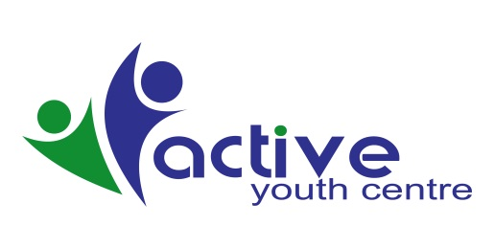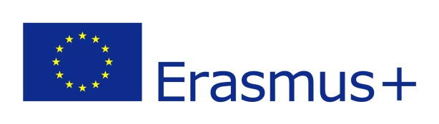
DESCRIPTION OF THE PROJECT
The art of wise and insightful dialogue is a core value of every conversation, whether it is as high level political summit, private talk or business transaction. Unfortunately, in the modern world communication is frequently limited only to shortcuts, signs and short messages. The lack of mutual understanding is a source of seemingly unresolvable conflicts and misunderstandings affecting mainly youth. The project STEP IN is created to help equip youth workers with tools that will enable them to cope with those issues as well as implement good practices in real-life situations.

During the training course we will focus on teaching advanced techniques in multicultural communication. Young people will have a chance to learn about various meanings of sings in different cultures and environments and the importance of decoding them. They will learn how to identify various types of conflicts (conflict of values, generations, structures, relations, access to information etc.) arising on that background and will explore different methods of resolving them. During all the sessions participants will be working on developing different negotiating styles and strategies and deepening the knowledge about Alternative Dispute Resolutions

The whole training will have a form of a field game simulating a real-life scenario of a conflict taking place in imaginary land of Atlantis. The participants will represent different parties to the dispute and through the series of workshops and lectures learn how to approach and resolve it. They will develop both theoretical (such as strategic planning) and practical skills (i.e. public speaking, conducting a successful mediation, negotiating in extreme conditions). The scenario will be a chance for the participants to learn and practice different communication strategies (one-on-one, multilateral, during assemblies) with accordance to decision making procedures in their communities, countries and European Union. They will also be challenged to resolve contemporary issues that are present in European policy to demonstrate the importance of thoughtful argumentation and understanding. During the whole game participants will be assisted by professionals in the field of negotiation and mediation. The participants will be also engaged into active learning procedure and will allow them to learn from their own experience and discuss their choices.

OBJECTIVES:
- To explore the topic of multiculturalism and intercultural dialogue;
- To underpin the importance of decoding messages and intents depending on their cultural background;
- To practice different communication styles;
- To learn about origins of different types of conflicts and possible methods of solving them;
- To promote and explain Alternative Dispute Resolutions;
- To teach in practice skills relevant to effective negotiation and mediation’
- To promote active participation of youth in civil society;
- To create a field for further cooperation and development of new projects

ACCOMODATION & VENUE
We will stay in “Center Hotel” Tallinn Estonia
This is a nice place near the old town of Tallinn
You will be accommodated in rooms with the capacity of 2-3 persons
Rooms are clean and simple with bathrooms inside. It is a 2 star Hotel and answer for all standards of European hygiene norms. We will try to keep national groups in rooms, but first of all we will follow to gender differences.
Bed linen and towels are provided.
Wi-Fi is available.
For more info about the Hotel check here: http://www.centerhotel.ee/en/
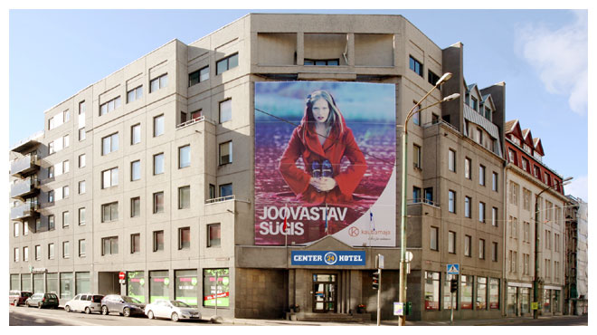
Work Place – central Tallinn Youth Centre
All project activities will be held in central Tallinn Youth Centre, which is located 5 min by walk from the Hotel.
All relevant equipment and materials will be provided by programme and participants can easily use it. By organizers you will receive folders, books and pens for making own notes.

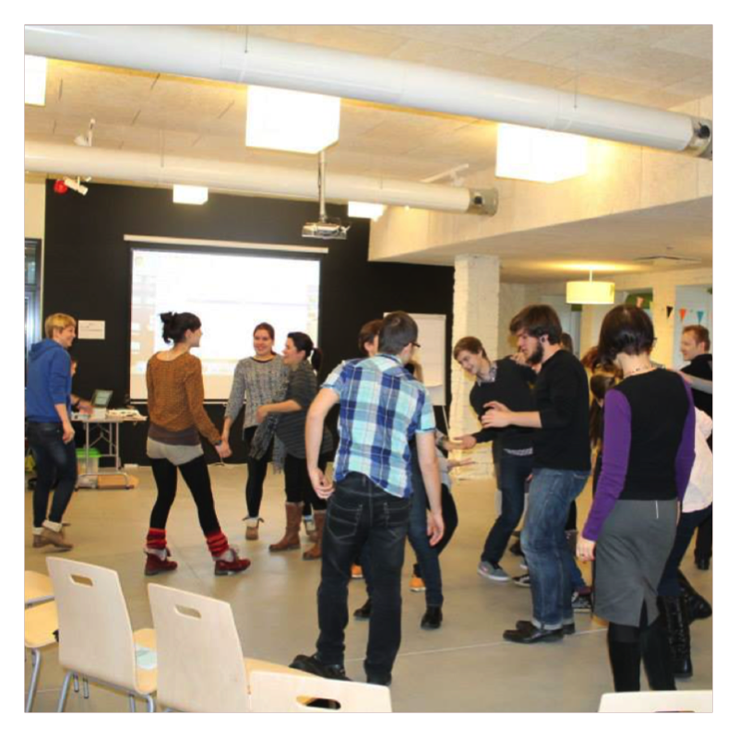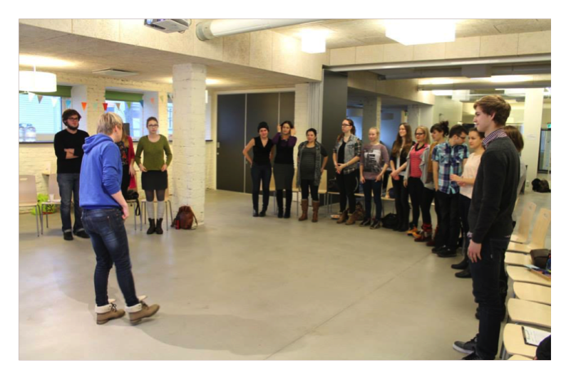

HOW TO GET THERE?
Each participant will have own arrival and departure time. We are responsible to meet whole groups and pick up you to place where will be project organized. Some participants has to come to the Hotel by their own, because a lot of people come earlier or separately and we do not have a lot of recourses that to meet everyone. By the way, from airport, port or main coach station it is very easy to pick up project venue. The detailed instruction how to pick up Hotel you can see below.
Arrival in Tallinn – 07th of November, after 15.00 check in (Dinner in the first day will be provided in the Hotel for each participant if different time, according to arrival time. Our staff will meet you there after 15.00)
Departure from Tallinn- 14th of February 2015 after 12 check out (Breakfast is provided by us in Hotel)
Hotel address: Narva mantee str 24 / F.R. Kreutzwaldi 2
Contacts: (+372)686 5202, (+372)51945202
Airport:
As public transport from airport you can take bus №2. You have to go to city center, check information here - http://www.visitestonia.com/en/travel-transportation/travel-to-estonia/by-air/lennart-meri-tallinn-airport?site_preference=normal
Ticket cost 2 EUR, you can buy it in the bus.
You can also go by Taxi, it will be no more than 10 eur (even less) and you will come exactly to the hotel. Yellow taxes are staying near the airport.
NB! Pay attention, we can’t cover taxi expenses, this is your own expenses.
Coach station:
As public transport from airport you can take bus №2. You have to go to city center, check information here - http://www.visitestonia.com/en/travel-transportation/travel-to-estonia/by-air/lennart-meri-tallinn-airport?site_preference=normal
Ticket cost 2 eur, you can buy it in the bus.
You take tram. It is very easy to go pick up hotel if you will use tram.
You can also go by Taxi, it will be no more than 5 eur (even less) and you will come exactly to the hotel. Yellow taxes are staying near the coach station.
By walk – 15-20 min
Port:
From airport to hotel you can go by walk. It takes 10 min. The second option is to go by Taxi, it will be no more than 5 eur (even less) and you will come exactly to the hotel. Yellow taxes are staying near the airport.
IMPORTANT Extra-days: following the guidelines of the Erasmus+ programme the travel must be realised by the participants within a maximum of 4 days from the project’s dates (arrival max 2 days before the project and departure max 2 days after the project) In case of longer stays the travel might not be reimbursed. Food and accommodation for extra-days will not be covered by the organisers.
VISAS
Participants who require visas should send us, together with the application, all your passport details (number, expiry and issue dates, issuing country, full home address, full name as in the passport). Please check in the Estonian Embassy in your country if any other information is necessary. We will issue an invitation letter for you, but the entire process will take some time, that’s why it is very important that you send us all the information as soon as possible, not later than application deadline.
PARTICIPATION FEE
Participation fee in this project is 20 EUR.
INSURANCE
The organizers do not provide participants with any form of insurance for the time of the project. That’s why you are strongly advised to make sure you have a valid medical insurance. We will not be able to reimburse any of your losses so it is better for you to take care of that in advance.

FOOD
Three times per day will you will be provided with meal, which answer norms of hygiene and special needs of participants.
We would like to inform participants that we are planning to eat in different places.
Breakfast – every morning in the Hotel
Lunch – everyday in youth centre
Dinner – every evening in different restaurants or in youth centre. We will also manage ones dinner in typical Estonian restaurant.
Two times per day will be provided coffee-tea breaks to all participants
If you have any dietary needs please inform us in advance in the application form.
TRAVEL REIMBURSMENT
The costs of travel will be reimbursed according to Erasmus+ travel framework up to:
Armenia | 360.00 EUR
Belarus | 275.00 EUR
Czech Republic | 275.00 EUR
Georgia | 360.00 EUR
Germany | 275.00 EUR
Hungary | 275.00 EUR
Norway | 275.00 EUR
Poland | 275.00 EUR
Spain | 360.00 EUR
Ukraine | 275.00 EUR
IMPORTANT! For us to be able to reimburse your travel we will need you to submit original travel documents: E-ticket, Invoice, Proof or payment or receipt, Boarding passes. Please remember to prepare all the documents in advance.
Reimbursement will be given to NGO representatives by bank transfer after the Training course when participants submit report of the mobility. We will reimburse money to one bank account of each organization. Reimbursement will be given according to travel cost limit sums and according to given documents. If you spent less than your travel limit, you will receive this price because we need for each given sum invoice or bills.
MONEY
Official currency in Estonia is EUR.
Credit and debit cards such as Visa, MasterCard, Maestro are accepted in most of the shops, restaurants and hotels.

WEATHER
In November temperature may range from 1 to +10 ⁰C and it can be raining or even snowing. Take that in mind while packing your suitcase!

THE GAME
The entire project is based on a form of field game (RPG). For those seven days you will not only travel to Krakow but to a faraway land of Atlantis where people and customs are much more different from everything that you may already know… So prepare yourself to take part in this adventure and if you have any things or ideas that may contribute to the exploration of Atlantis – take them with you, we will sure use them!
WHAT TO TAKE WITH YOU?
- Warm clothes, a hat and a pair of gloves.
- Warm and comfortable shoes
- Regional food, drinks, costumes, songs, films, games – everything connected with your culture will be great for Cultural Evening
- Something special that can represent you as a citizen of Atlantis region (maybe a funny hat, a flag, special symbol or mascot – it’s up to you!
- PowerPoint presentation of negotiation culture in your country (we will send you more details and an example later). It is crucial for you to prepare that in advance because we will need them for training sessions!
- Ideas for new projects which you would like to share, together with some materials about your organisation
- Good humor and a lot of motivation
ABOUT TALLINN AND ESTONIA
Want to know more? We recommend you to visit these websites to get a taste of Estonia and Tallinn! http://www.estonia.eu/
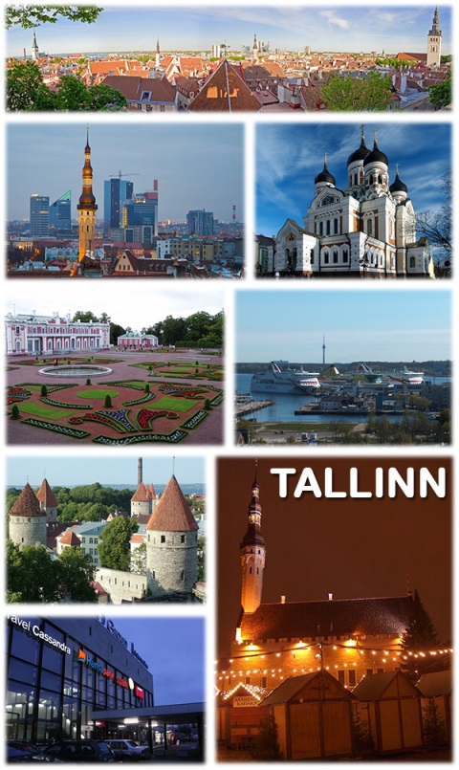
source: www.wikipedia.pl

LIST OF PARTNER ORGANIZATIONS
Stepanavan Youth Centre | Armenia
Belarusian Youth Public Union New Faces | Belarus
Be International | Czech Republic
NGO Youth Club Active | Estonia
Youth Association DRONI | Georgia
Experiment e.V. | Germany
RGDTS ROMA PARBESZED AZ ONKENTES SZOLGALAT ALTAL | Hungary
Narviksenteret | Norway
Stowarzyszenie Rozwoju I Integracji Młodzieży STRIM | Poland
KAEBNAI | Spain
Center for European Initiatives | Ukraine

CONTACT:
For the logistics question please contact representatives of hosting organization
Darja Djatsenko – darja.djatsenko@youthclubactive.com
Lena Gusseva – lena.gusseva@youthclubactive.com

If you have any questions considering content please contact us via e-mail: decodetc@gmail.com

SEE YOU SOON!

